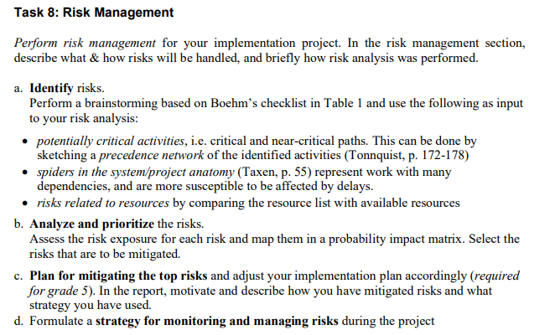

8a) **IDENTIFY RISKS**

8b) **ANALYZE AND PRIORITIZE THE RISKS**

8c) **PLAN FOR MITIGATING THE TOP RISKS**

8d) **STRATEGY**